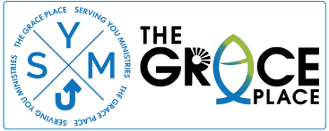

11th Annual 5K Race for
Serving You @ The Grace Place

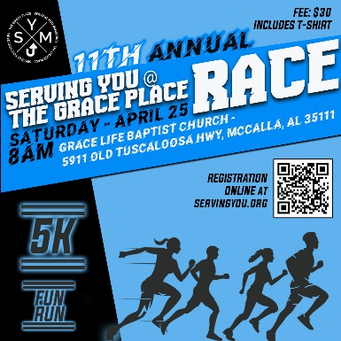
RACE DAY: Saturday, April 25, 2026

PRE-RACE REGISTRATION: 6:30AM - 7:30AM

START TIME: 8AM

LOCATION: Shadow Lake @ Grace Life Baptist Church (5911 Old Tuscaloosa Hwy, McCalla, AL 35111)

Registration for Track Runners:

5K Entry Fee = $10
Professionally timed 5K race. Includes a T-shirt* and prizes for top finishers.

Fun Run Entry Fee = $10
A fun 1-mile run/walk. Each registration includes a T-Shirt*

*T-shirt sizes can only be guaranteed if registered before April 15th!

Mail registration form and payment to: PO Box 1110, Trussville, AL 35173
Make checks payable to: Serving You Ministries
and note “5K Race” on the memo line.

Name: ______________________________________________________________________
Address: ____________________________________________________________________ Phone #: ___________________________________________________________________
Email Address: _______________________________________________________________
Age (on race day): _______ Gender: _______ T-shirt Size: _________
I, the undersigned registrant, hereby release, remise, waive, and forever discharge the sponsors, The Grace Place, and any and all other supporting groups of this said racing event, together with all their officers, agents, officials, and employees from any and all liability, claims, demands, actions, or cause of action whatsoever arising out of, or related to any injury, illness, loss, or damage, including death, relating to participation in the aforesaid event. I further state I am in proper physical condition to participate in this event.

Signature: ____________________________________ Date:__________________

